Application form Letje Lips Amsterdam Merit Scholarship (LLAMS)
Fill in and complete this application form in accordance with the instructions for the required documents (see below).

Please make sure that both your scholarship and Master’s application are complete and submitted by 15 January 2022. Incomplete scholarship and Master’s applications will not be taken into consideration.
Information about the eligibility criteria for the LLAMS can be found on the website of the Graduate School of Humanities.

Full name: _______________________________________________
UvAnetID/student number: _______________________________________________
Master’s programme(s): _______________________________________________
_______________________________________________
Date (dd/mm/yyyy): _______________________________________________

Instructions for the required documents:
- Motivation letter (maximum 500 words)
The Letje Lips Amsterdam Merit Scholarship will be awarded to students from a non-privileged background who wish to use this international programme to improve themselves and who show a passion for the development of a just, inclusive and multicultural world.
Please explain in your motivation letter why you consider yourself a suitable candidate for the scholarship based on your background and aspirations.
- Curriculum vitae/Resume
Please mind that your cv/resume should include all the points mentioned in the sample included in this form.
- Academic background caregiver(s) (maximum 200 words)
Please answer the question in the space provided in the form.
- Academic records
Official and up-to-date transcript of records including your Grade Point Average (GPA). Also include your diploma, if you have already finished your degree.

- Motivation letter (maximum 500 words)
The Letje Lips Amsterdam Merit Scholarship will be awarded to students from a non-privileged background who wish to use this international programme to improve themselves and who show a passion for the development of a just, inclusive and multicultural world.

Please elaborate on why you consider yourself a suitable candidate for the scholarship based on your background and aspirations.
Replace the sample letter below with your motivation letter:
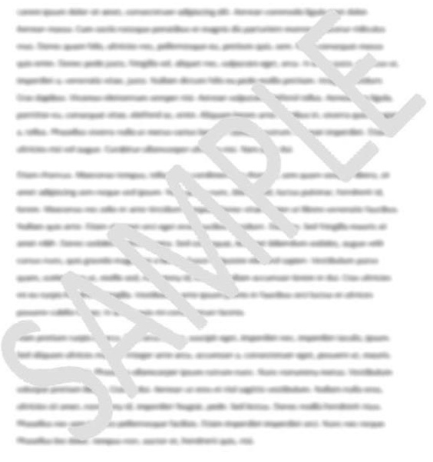

- Curriculum vitae/Resume
Replace the sample below with your own cv/resume. Please mind that your cv/resume should include all of the elements mentioned in the sample.
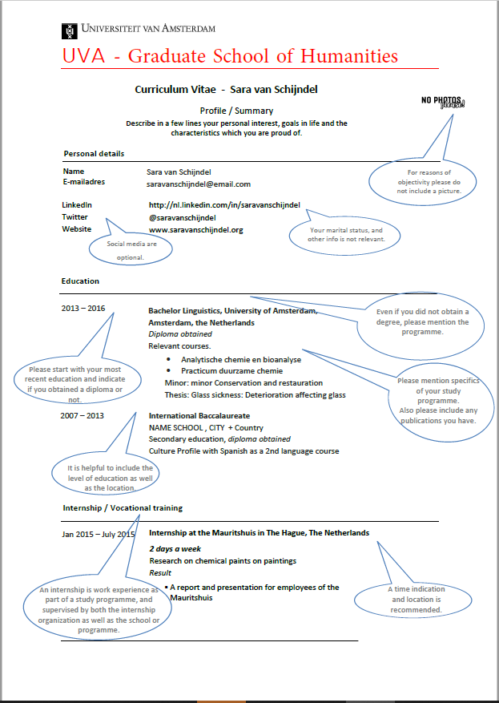

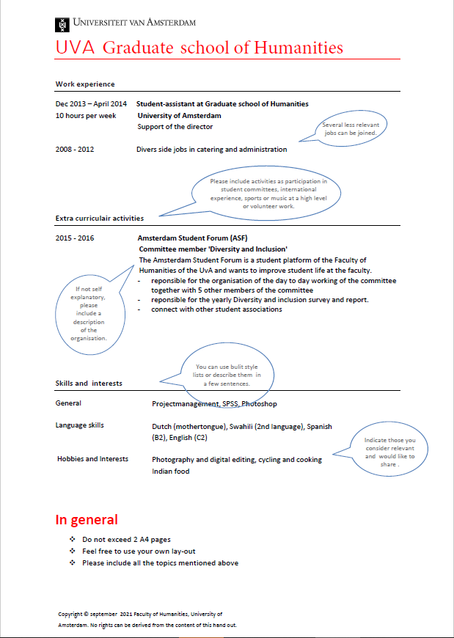

- Academic background caregiver(s)
Would you identify yourself as a first generation Higher Education (HE) student, i.e. neither parent or caregiver holds a Bachelor's degree? (HE would be all post-secondary education, for example everything from level 6, 7, 8 in the ISCED classification by UNESCO).
Please explain in the box below (maximum 200 words).

- Academic records
Grade point average (as stated on your transcript): _______ out of _______ (i.e. 8 out of 10). Please use the GPA calculation provided by your home university.
Transcript of records
Replace the sample below with your own transcript:
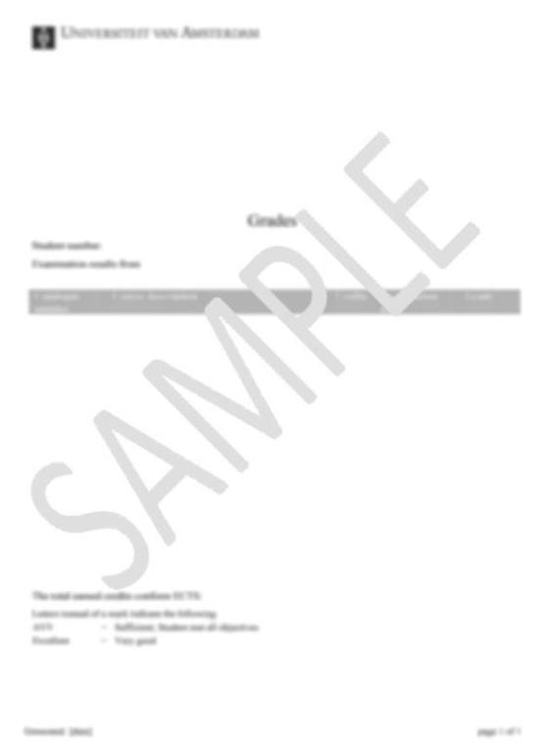
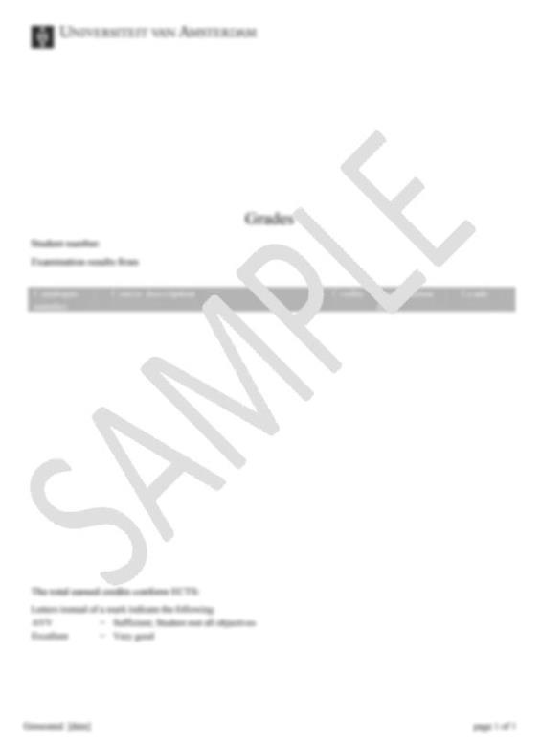

Diploma (if you have already finished your degree)
Replace the sample below with your own diploma:
